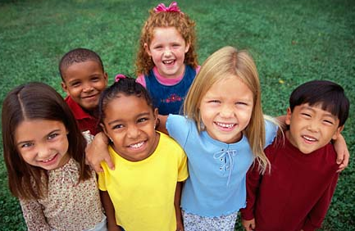
My neighbour and me …..
Connecting our communities

Name of school ______________________________________________________________
School contact ______________________________________________________________
Contact email address ______________________________________________________________
Please circle the words which you feel best describe your school and its location
Rural multicultural urban monocultural outward looking
We would very much like to be involved in the project and can commit to :
- Establishing a connection with our nominated Newcastle/County Durham partner school,
- Exchanging information with our partner school about our class and school in advance of the event,
- Attending the event in Durham with 10 Y5 pupils and accompanying staff(if permitted)
- Maintaining the link with our new partner school in the 2020/21 school year.

Please return this pro forma to michele.thorns@durham.gov.uk
There are only places for six schools from each local authority area and we expect there to be a good deal of interest in the programme.

