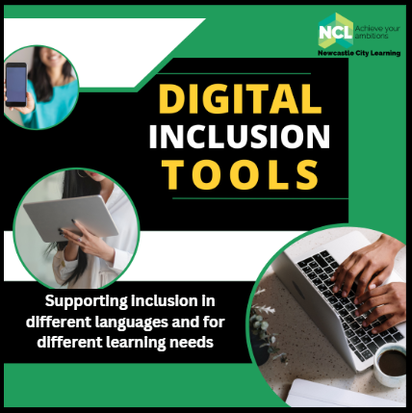
Digital tools for multilingual environments
Webinar notes from 14th March 2023
Presenter: Isa Wilson, Newcastle City Learning
This webinar was provided free for anyone in the North East, as part of Express Yourself: North East Festival of Languages. Isa Wilson presented an overview of a range of free digital inclusion tools, which are already embedded in the software that most people have available, such as Microsoft, google and other platforms.

Newcastle City Learning, works in 3 Council spaces and is also delivering in community venues. They are also delivering training on digital inclusion tools for Newcastle schools and there is funding for Newcastle schools for training with Isa, to access this contact sarah.edgar@newcastle.gov.uk
Increasing access with everyday digital tools, that could support a more inclusive experience for those with different languages or who are learning a language, people with different learning needs or sensory impairments. The webinar focused on free to access tools that could provide more inclusive learning or communication experiences.
The webinar introduced the following free tools:
- PowerPoint Live (provides immediate written translation into a wide range of languages)
- Immersive Reader (reads text, translates text, highlights words, picture dictionary, languages options)
- Otter AI (Transcripts)
- Class Dojo (for classrooms, instant translation, scheduled messages and setting tasks)
- Google Meet (closed captions)
- Microsoft Lens (for text and images)
- Google Lens (for text and images)
- Say Hi (for interactive conversations)

- POWERPOINT LIVE
PowerPoint Live is embedded into Powerpoint online on 365 version (not the desktop version). Any powerpoint on the OneDrive can be used with this new system, even old PowerPoints that are uploaded in new version.
Presenters need to set the settings in PowerPoint live to ‘anyone’ and not the default setting of ‘people in your organisation’ to make it available to all. The presenter using PowerPoint Live will automatically be given a QR code and a weblink that is on screen and can be accessed by those watching the presentation on smart phones or ipads (or equivalent) and the audience can follow the link to access the translations in other languages.
The presenter in PowerPoint Live can switch subtitles on (and this is also available in the desktop version) – so people can see them.
As the presenter is speaking, once the audience member has followed the link, they can choose the language that they would like to access. There will then be a transcription on the audience member’s screen in the language they have chosen, specific to their needs. There is an extensive list of languages available.
If the presenter is running a presentation with a number of people in different locations, they can see it on their own screen and also get the words you are presenting by using the transcription in the language they choose. The languages will appear in writing while the person is speaking.
The unique QR code and the PowerPoint Live weblink for that particular presentation will only be available for the duration of use and then is deleted. It will be on screen at all times.
There is an option in the settings to give feedback – such as adding a new language to those already available. The more people who ask for a particular language, they are more likely to add it.
Audience members can send a reaction in PowerPoint live – it does not collate the reactions, is just live
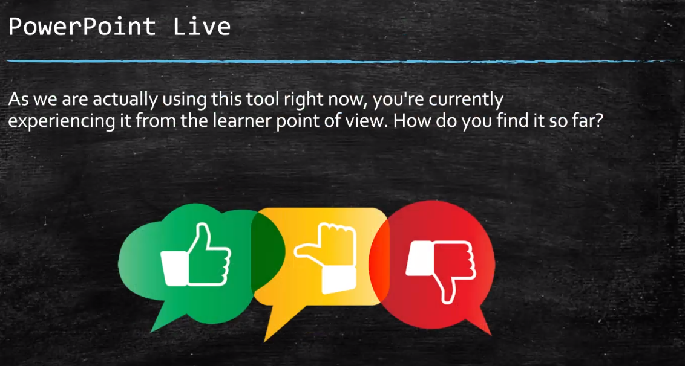
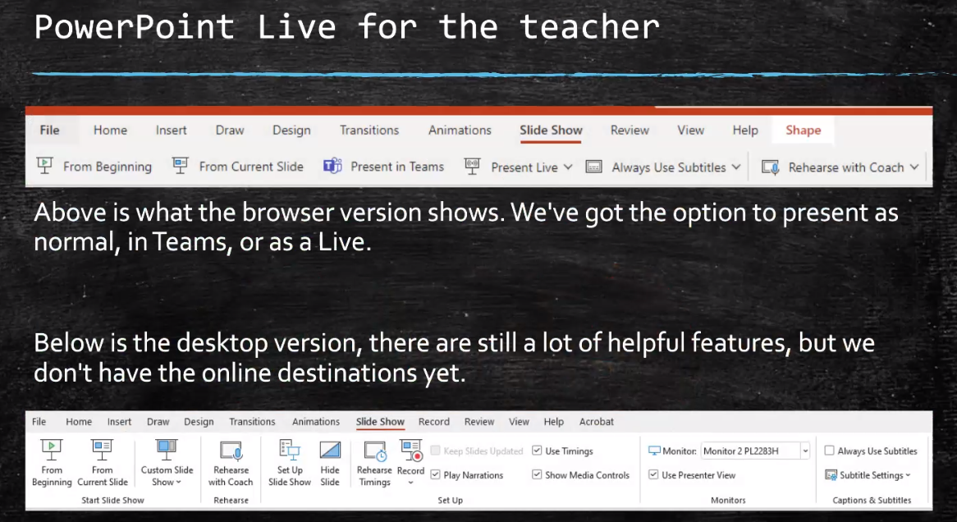
Using PowerPoint Live in Teams
- Much easier if you are using two screens, you can drag things over and makes it easier to move things around the screen. Have Teams on one screen and then powerpoint live on the other
- If PowerPoint Live is on, will take up the full screen and if you only have one screen you wont be able to see anything else.
- You can pause the powerpoint, do what you need to do on teams and then restart the session at the same point you left off
- Desktop version of powerpoint has options ‘present from the beginning’, ‘present from current slide’ or ‘rehearse with coach’ (use of AI – can be quite brutal)
- You can record your session as a video
- In 365 – it says an option is ‘present in Teams’ – doesn’t work well if you use any of the other features. There is an option under share to open Powerpoint live, but it is not the same as Powerpoint live.
- Find the Present Live button and use that – with option to present to wider people or those in your organisation – so choose as appropriate.
- Sometimes the Teams and PowerPoint live microphones don’t work – you may need to plug one into your computer, such as a USB microphone. Fairly cheap. Means you can use both at the same time.
- There are also subtitles. You can click you should always use subtitles – choose that option
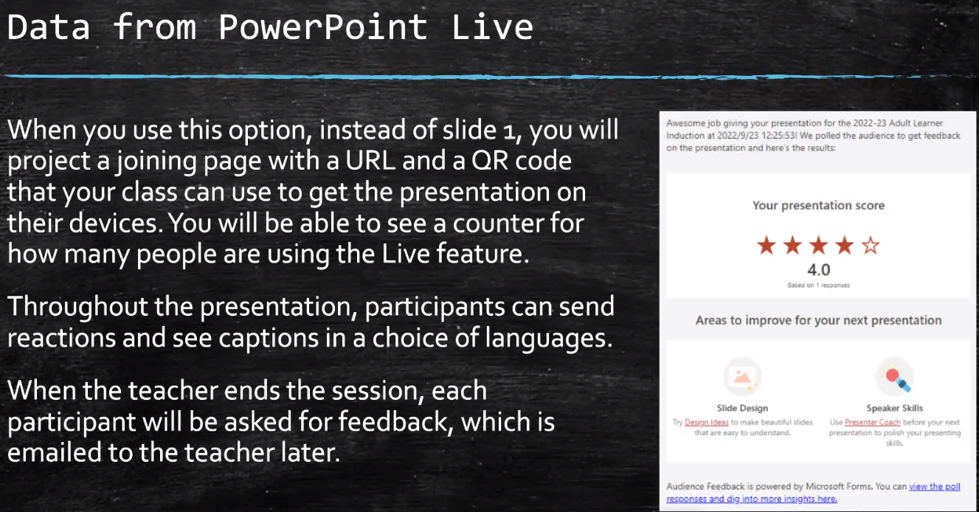
- All participants will receive a short survey about what the experience of powerpoint live was. You will have a star rating and also view poll responses, for any specific comments.
- You cannot change the questions asked. You can design your own Microsoft forms. It is simple if you enjoyed the speaker and slide design.
- There is a temporary anonymous list created for feedback, it is anonymised to the presenter, does give the option to send a form out afterwards, within 30 days, then the list is deleted and you will not have access to the information
- Isa has suggested to Microsoft that the questions could be added by the presenter, so an editable feature that could be used

- IMMERSIVE READER

- Immersive Reader is a very useful tool which is free and available via Microsoft 365.
- It is built into Word, Excel, also PowerPoint and OneNote
- It changes the view of the text and gives you the option to hear it as well as read it
- You can change the background for people with sight impairment
- Can be limited to 3 lines or one word as a time
- Text can be read at a faster or slower speed
- Can highlight particular areas of speech, adjectives, verbs etc,
- There is a picture dictionary
- There is also a set of language options – you can see options for the word, as well as it spoken. It will also try to translate the whole text and read it in the selected language
- Immersive reader should already be installed on the 365 version of Microsoft – desktop versions may need to be updated. The desktop version is similar to the online version – available on the tabs
- When you finish, you hit the close button and it gives you the original document, looks like nothing has changed. Can listen to articles rather than read them.
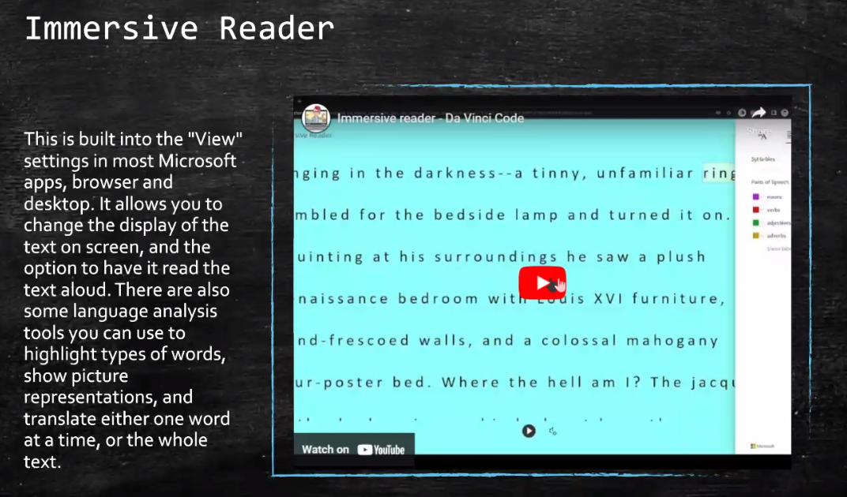

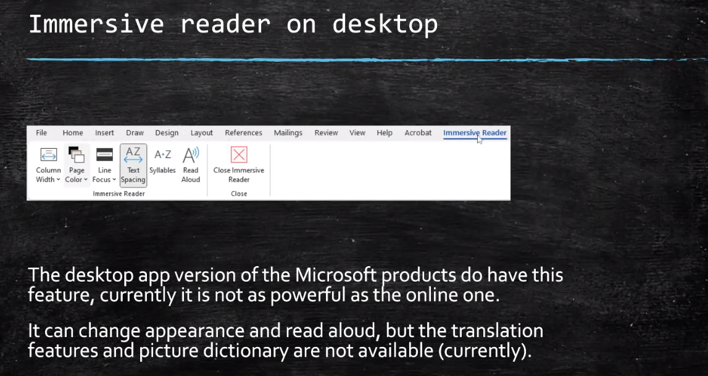
There is not an identical google version, if you use Chrome, it has to be added manually – but it does to the same job as the Microsoft product. It is free for now.
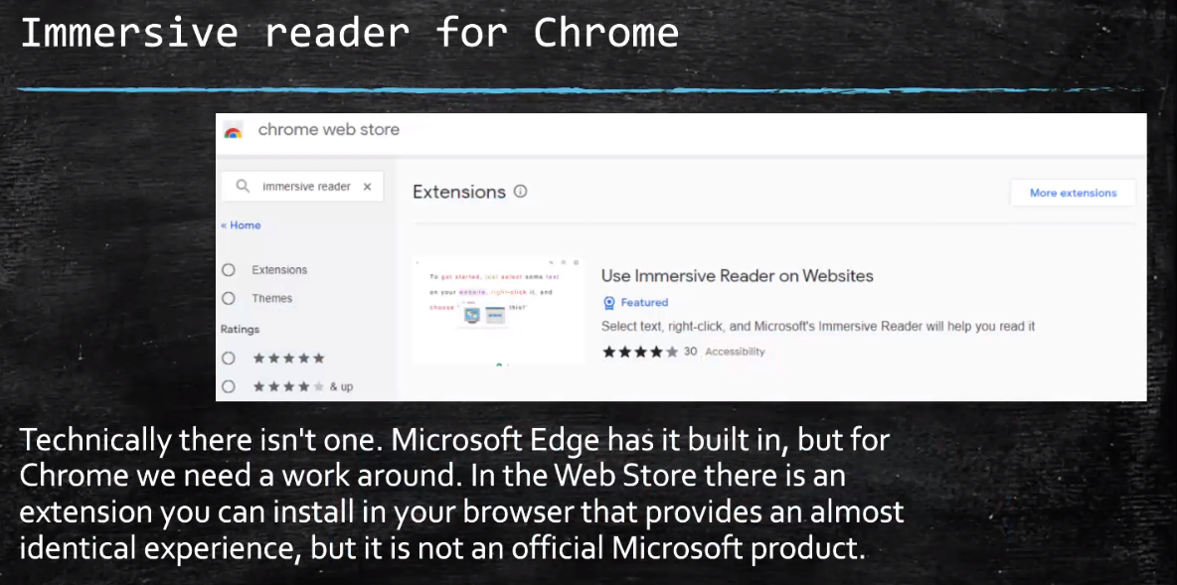
There is also an extension you can add in for Chrome: Can also save highlights as a collection
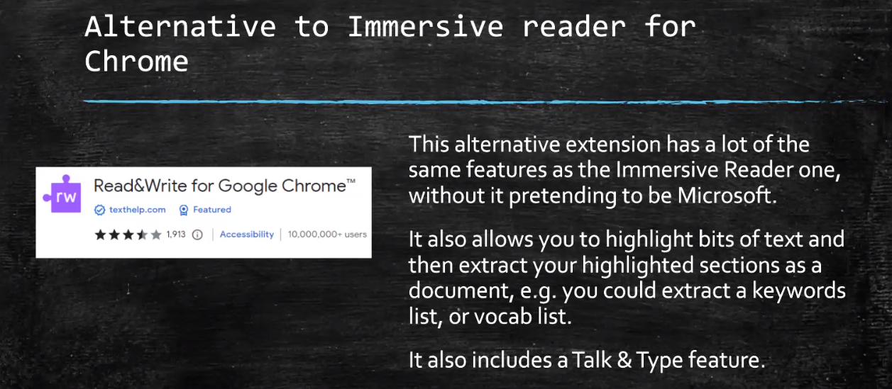

3. OTTER.AI (Transcripts)
- Otter.ai is on most mobile devices or you can get a Microsoft and Google Chrome plug in, which will record your conversation and identify different speakers.
- It can produce an editable transcript, gives timestamps, you can select speakers and you can transport this. You may use this for meeting.
- Use a mobile, record the meeting and you can then share it as a document or as a recording. It is free up to a certain amount of minutes per month.
- Google gives you unlimited email addresses. Google doesn’t see email with +otter, Otter does so you can filter it.
4. CLASS DOJO
- Works well for pastoral work, rather than classes
- App for any phone or tablet
- Members of the class pick an icon to represent themselves)
- Teachers can assign merit points and demerit points
- Class Dojo have added options for parents at home. Teacher can send a message and they can select what language they want to read that message in. They will see it in the language of their choice. Good for reminders for permission slips, setting homework, things happening at school. Means you only write it once in English. Would need to speak to IT team about making it available on ipads etc and educating parents how to use it.
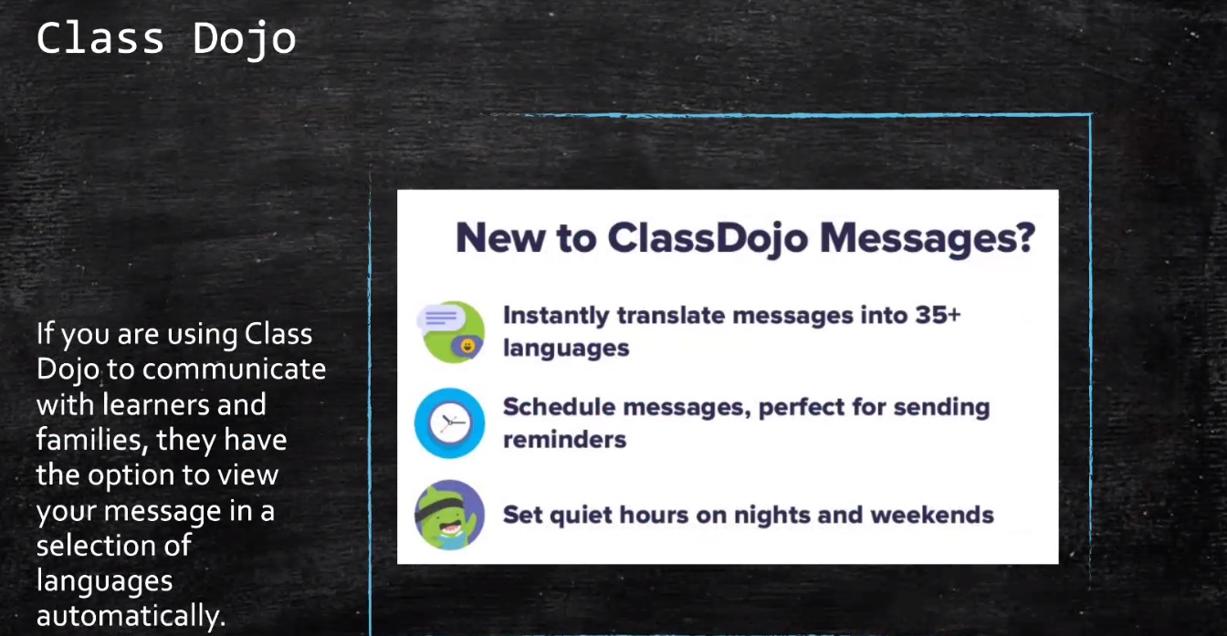

5. GOOGLE MEET
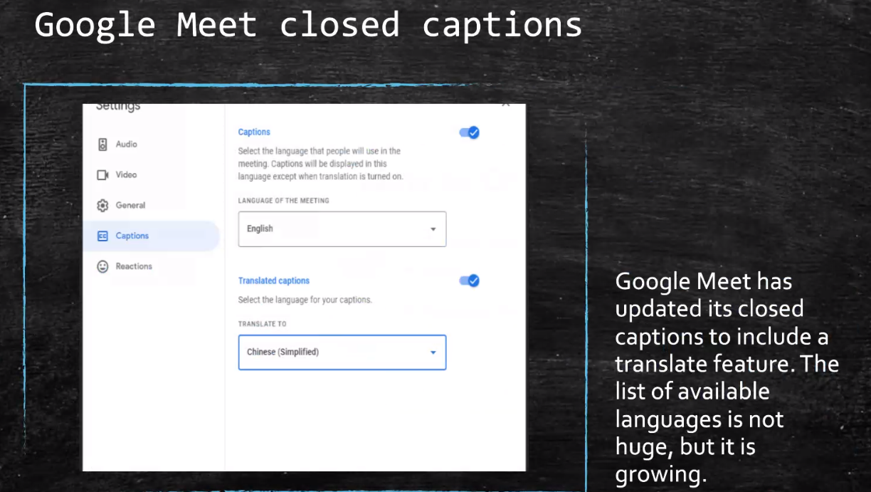
- Google meet – relatively new, can select languages.
- Not as extensive as Microsoft languages, currently only 7 or 8 languages available

6. MICROSOFT LENS
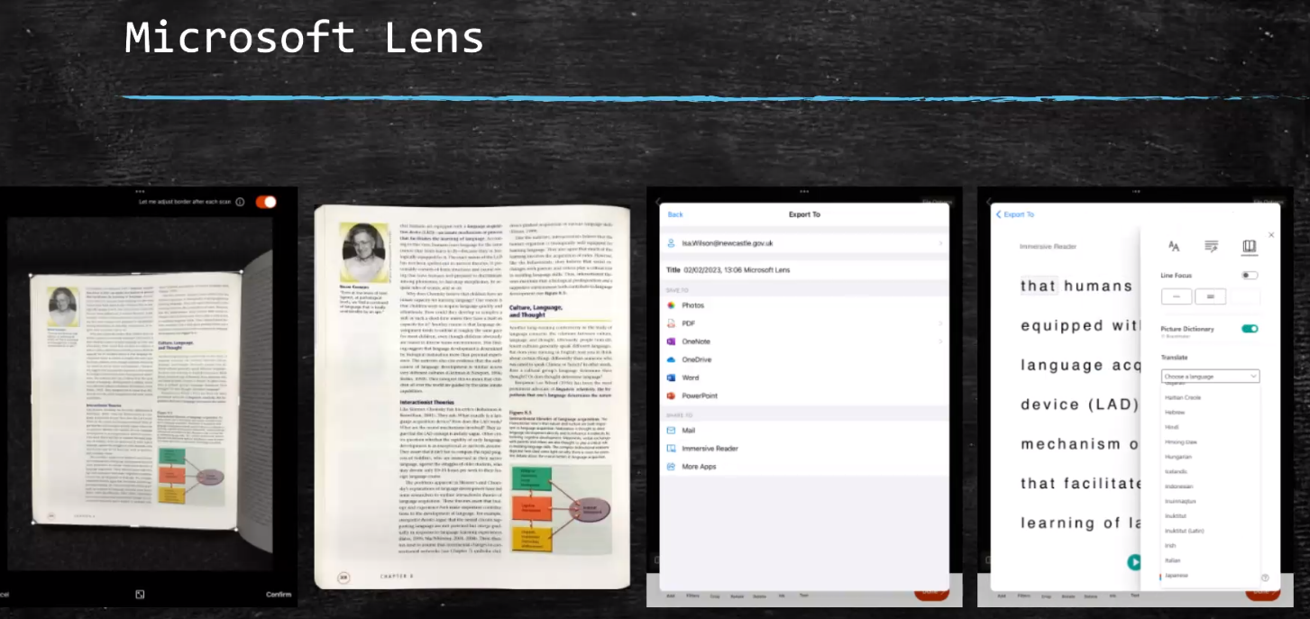
- Can take a picture of a textbook, allows it to be cropped, then turn it into a cropped image, then options of what want to do, can save as image to photos, pdf, turn it into a word document or put it into powerpoint, also option to view it in immersive reader.
- Same options then to change colour, speed of reading it, language etc
- Good for worksheet or text that need to send home, very useful
- If people use onedrive could put it into a shared folder and have resources in the same place, or email it
7. GOOGLE LENS
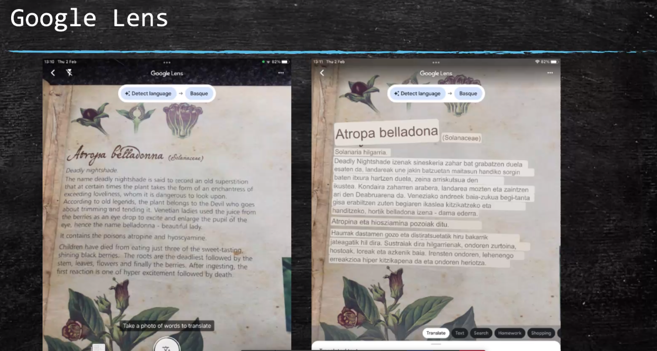
- Similar, some options, can translate, set as homework, also internet search feature
- Instead of translating it, it is giving the text in augmented reality, it has put the translation over the top
- It can do the translation in real time, as a photo or automatically on screen in real time (very useful for menus)
- It can also read handwriting and translate into home languages (if handwriting is neat)

8. SAY HI
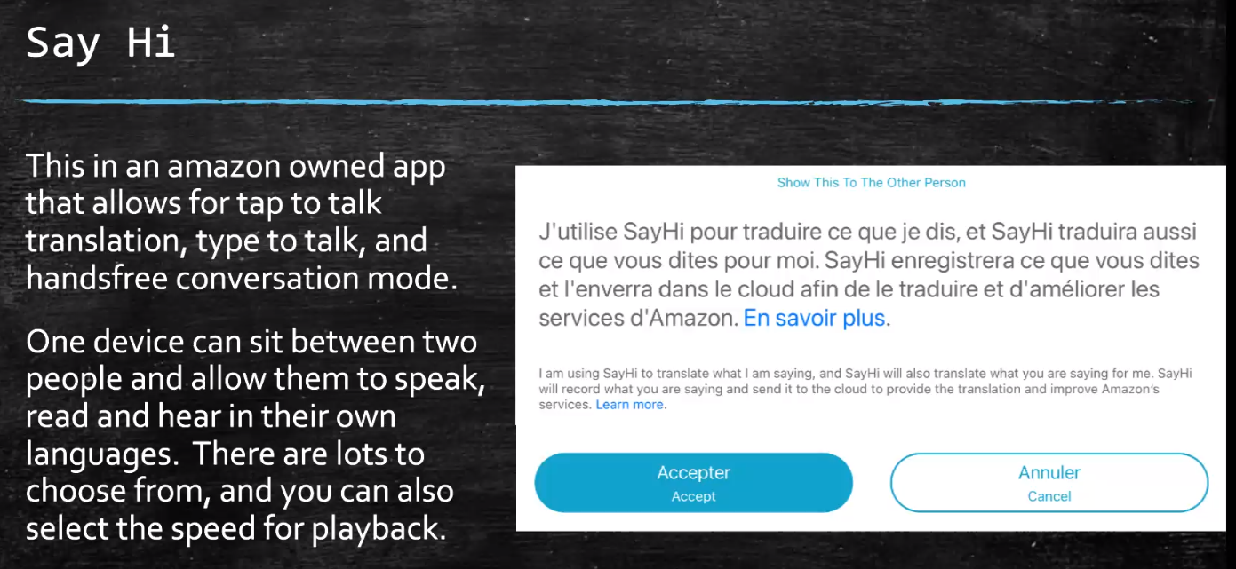
- Amazing tool to enable people to communicate with other people in real time
- You can type in, or tap to talk, it will listen and translate
- You can set to conversation mode, where it just listens with the microphone open. You talk, it will listen and when you pause, it will translate it and then speak in the language you chose – (e.g. English to French) then in reverse for the other person (e.g. French into English)
- May be useful in a parents evening or any setting where the conversation needs to flow
- It asks on the first screen – tells you what it is and then you accept or decline
- Can also use it to practice pronunciation – type in the language and then it will read it out
- Can use it to practice English words
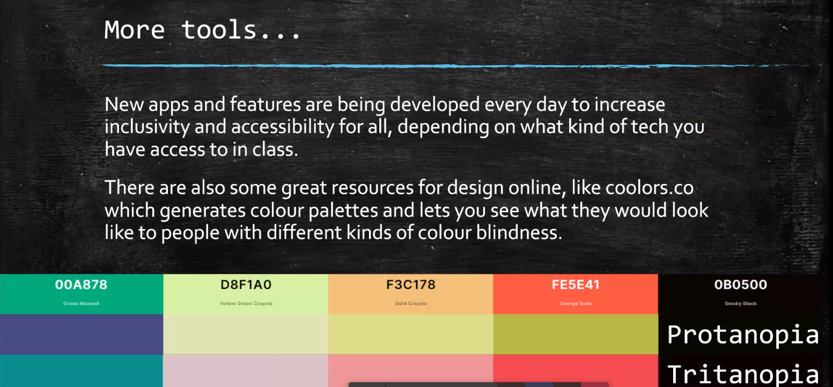
- Generates a colour palate, for printing, internet or powerpoint
- You can view it with what the colour would look like to people with different visual impairment
- It can then be adjusted for people who have different colour vision, to ensure that there is a contrast
- Can inform what website colours you use and that they would be accessible. Allows you to check this

