Profile of Gelsenkirchen

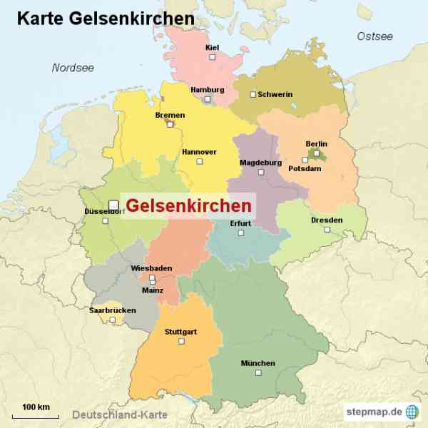
Newcastle upon Tyne and the German city of Gelsenkirchen have been twinned since 1948.

Gelsenkirchen has five more twin towns, but the twinning with Newcastle upon Tyne is the oldest. In the past both cities were major centres of coal mining and heavy industry. This is the reason why the cities were connected. Even though the collieries and mines are closed today, you can still find a lot of buildings and memories from this time in Gelsenkirchen.

Gelsenkirchen is located in the west of Germany, in the heart of the Ruhr area. The Rhein-Herne Canal splits the city into a northern and a southern area. Each of these areas has its own city centre with shopping facilities. All in all, the city is divided into five different districts and has about 265,000 residents… and we have two town halls.

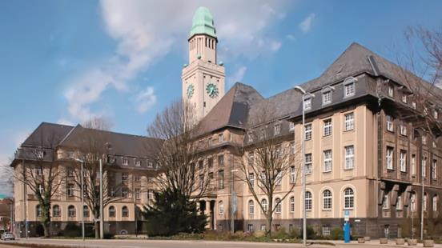 | 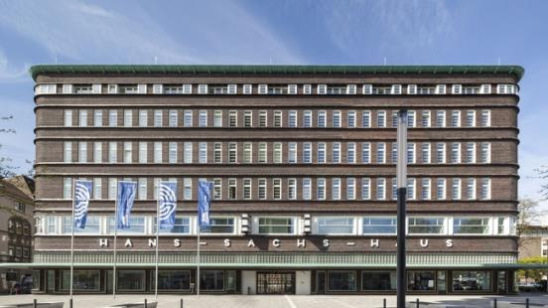

Most people know Gelsenkirchen as the hometown of Schalke 04, which is one of the biggest football clubs in Germany. World champion footballers like Manuel Neuer, Mesut Özil and Julian Draxler grew up in Gelsenkirchen and played for Schalke for a long time.

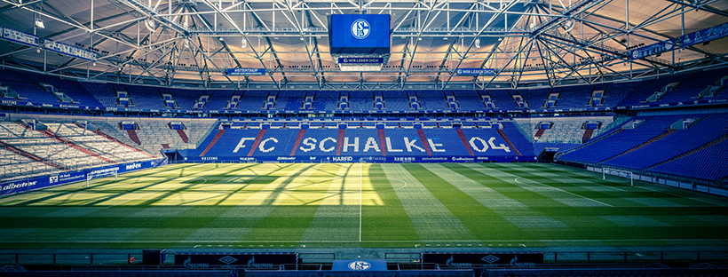

In addition to one of Germany’s largest soccer stadiums, Gelsenkirchen has a large zoo, several public parks, a great musical theatre and some beautiful old castles.

  Mayor Karin Welge  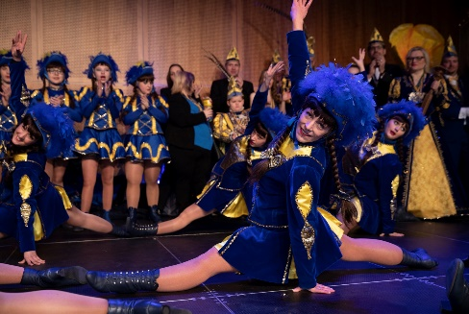 | 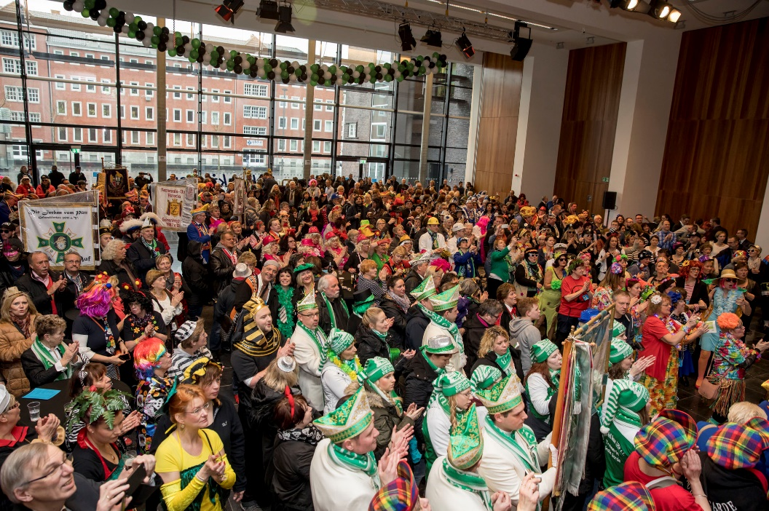
Karneval or Fasching in Gelsenkirchen is a special time | Parades and celebrations involve people of all ages and walks of life before Lent with distinct customs and traditions

During their 75-year partnership, Newcastle upon Tyne and Gelsenkirchen have had an intensive cultural, economic and administrative exchange. Both cities have organised several visits by delegations. These trips have included performances by choirs and youth theatre groups, or sport events such as soccer competitions. Even the police departments have been involved and organised job shadowing schemes to learn from each other.
In addition to several elementary schools, Gelsenkirchen has nine grammar schools, five comprehensive schools, four secondary modern schools and one technical college. Today children learn English in school from the first year onwards. Schoolchildren with a handicap have the chance to attend one of 30 inclusive schools. Furthermore, many schools offer full-time assistance. This enables parents to easily combine work and family.
In the past, teachers and schoolchildren from various schools started cooperation projects, matched up pen friends, and visited each other in the past, but we are seeking to set up new partnerships between schools. A lot of German secondary schools are still very interested in collaboration with schools in Newcastle. International Newcastle and Newcastle City Council (School Effectiveness) are providing support for new links.
English Martyrs Catholic Primary School has recently partnered with Rainbow School in Gelsenkirchen and will be part of the 75th twinning celebrations in September 2023, including working with a Gelsenkirchen born artist living in Newcastle to create an art project. In addition, Leibniz Gymnasium from Gelsenkirchen will be visiting Newcastle in August 2023 with 120 children and will have a civic welcome with the Lord Mayor of Newcastle, Cllr Veronica Dunn and a tour of the city. There are other celebrations being planned for September 2023.

